**AGILE SOFTWARE ENGINEERING**

**QUESTION BANK MANAGEMENT SYSTEM**

**TEAM – C**

C:\Users\Acer-Aspire R\Desktop\sprints\qbmslogo.jpg

**Presented by,**

Christian Levi  
Raj kiran Reddy Gunna  
Shiva Jyothi Angala  
Unni Krishnan  
Sefak Kahriman

**TABLE OF CONTENTS**

**CONTENTS PAGE NO:**

1. INTRODUCTION 3
2. MAIN OBJECTIVE 3
3. FEATURES 4
4. SOFTWARE REQUIREMENT SPECIFICATIONS 5
5. SYSTEM DESIGN 6-7
   1. DATA MODELS
   2. ER DIAGRAMS
6. SCRUM MEETINGS 8-12
   1. SPRINT 1
   2. SPRINT 2
   3. SPRINT 3
   4. SPRINT 4
   5. SPRINT 5
   6. SPRINT 6
7. TESTING 13-20

* CODE COVERAGE & FINDBUGS
* WEB PAGES

1. REFERENCES 21

**1.INTRODUCTION**

The main objective of the project is to keep the track of departments, courses, questions & answers that can be modified by admin and users. The admin provides access to the users and can create, preview, edit or update courses, questions & answers and can select the content to download or print. The admin will be able to view all the user’s information.

Users are teachers who can modify the courses, questions, answers of their respective courses, whereas admin can modify all the courses, questions and answers. The system also provides the security by giving permission for user registration. The system will check the user’s existence in the database and provide the set of services with respect to the role of the user.

**2.MAIN OBJECTIVE**

The main purpose of the project is meant to overcome problem faced by Institution’s/Schools/Coaching classes for competitive exams and other institutions by providing a question bank. The Question Bank System can easily generate a study guide for one subject/ course/ topic.

**3.FEATURES**

The Question Bank Management System differentiates Admins and Users by following features.

|  |  |
| --- | --- |
| **Admin** | **Users/Teacher** |
| User registration | User registration |
| Login | Login |
| View Dashboard | View Dashboard |
| Add/view all Departments | Add/view Department |
| Add/view/edit all Courses | Add/view/edit Course |
| Add/view/edit all Questions | Add/view/edit Questions |
| Add/view/edit all Answers | Add/view/edit Answers |
| Can generate Question Bank for all courses | Can generate Question Bank for specific course |
| Download Question Bank | Download Question Bank |
| Save the file | Save the file |
| Print the file | Print the file |
| Logout | Logout |

Fig 3.1 Features Table

**4.SOFTWARE REQUIREMENTS**

* MySQL
* Tomcat Server 9.0
* Spring Hibernate (JBoss Eclipse plugin)
* iText 5.5 – PDF generation
* Bootstrap – Front End
* Jenkins Continuous Integration
* Testing
  + JUnit
  + Code Coverage
  + Find Bugs
* Taiga Project Management
  + <https://taiga.io/>

**5.SYSTEM DESIGN**

**DATA MODELS**

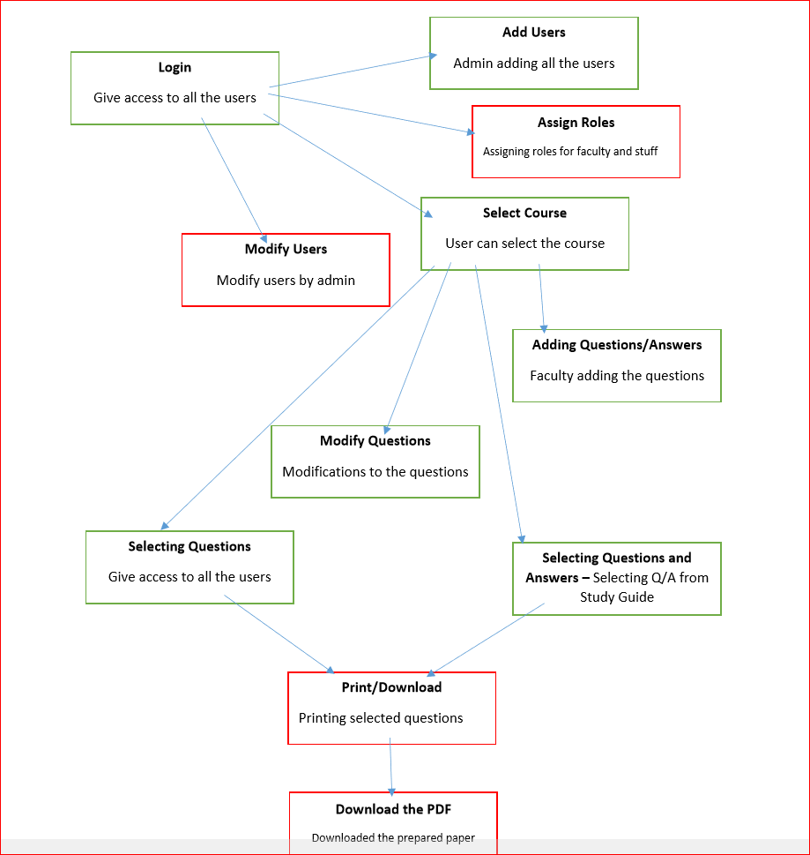

Fig 5.1: Data models

**ER DIAGRAMS**

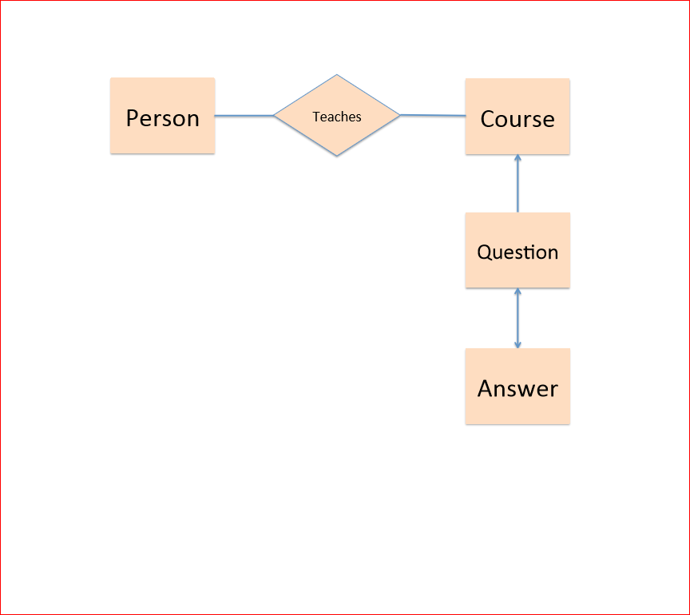 Fig 5.2: ER Diagram

**6.SCRUM MEETINGS**

**TOOLS USED**

* Team co-ordination: Taiga Project Management
  + <https://taiga.io/>
* XP programming practice
* Continuous Integration: Jenkins
* Test Coverage tools

1. **SPRINT 1**

**Scrum Master: Raj Kiran Reddy Gunna**

* Goals
* Creating a Simple QBMS GUI design
* Required features for the project
* Product backlog
* Required tools and installation
* DB schema and DB diagram
* Achievements
* Setting up taiga
* Creating product backlog
* Team collaboration
* Discussion on basic features of the project
* Creating DB schema and DB diagram
* Backlogs
* Features for the project
* Contents on GUI Design

1. **SPRINT 2**

**Scrum Master: Sefak Kahriman**

* Goals
* Setting up Repository for everyone
* Discussion on Web Content
* Discussion on DB tables and its contents
* Discussion on required tools as Hibernate and JBoss
* Working on User Registration page
* Working on adding Courses
* Achievements
* Setting up Oracle Database
* Changes on DB schema
* Creating DB Tables
* Discussion on Database
* Backlogs
* Oracle Database
* Hibernate and JBoss
* DB Schema and DB Tables
* Installing oracle DB
* Couldn’t complete adding Course

1. **SPRINT 3**

**Scrum Master: Christian Levi**

* Goals
* Installing MySQL
* Create basic Web contents
* User Registration page done
* Working on CSS files
* Working on DAO layer
* Working on QB features
* XP programming practice
* Achievements
* Installing Hibernate and JBoss
* Creating Web contents as Login, Answers and Questions
* Working on adding Courses completed
* CSS files completed
* DAO layer for the project is completed
* Backlogs
* Create Navigation bar
* MySQL DB
* Dashboard

1. **SPRINT 4**

**Scrum Master: Unni Krishnan**

* Goals
* Junit Testing
* Improving web contents
* Create Dashboard
* Achievements
* Changes on DB Tables’ attributes
* Creating Web content as Login, Answers and Questions
* Adding Entities to DB tables
* Backlogs
* MySQL DB
* Junit Testing
* Code coverage and find bugs plugin

1. **SPRINT 5**

**Scrum Master: Shiva Jyothi Angala**

* Goals
* Creating all web contents with all features
* Creating admin
* Adding Questions & Answers
* Admin view
* Junit testing for all classes
* Achievements
* Dashboard is finalized
* Logging in
* Creating Person
* Creating Questions/Answers
* Creating Web content as Login, Answers and Questions
* Side navigation bar added
* Backlogs
* Finalize web contents
* Creating PDF document
* Testing all functionality

**SPRINT 6**

* Goals
* web contents with all features
* PDF documentation
* Creating admin
* Junit testing for all classes
* Achievements
* Dashboard is finalized
* Download feature
* Creating Questions/Answers
* Creating Web content as Login, Answers and Questions
* Side navigation bar added
* Code coverage running successfully
* Bugs fixed through Find bugs
* Implemented pair programing
* Backlogs
* Quality testing
* Created PDF document
* Working on Invalid credentials
* Validations check

**7.TESTING**

We used JUnit testing framing for java programming. Used the test driven development implementation to accelerate programming speed and increase the quality of code.

* Used Code overage and Find Bugs Eclipse plugins to ensure the quality.

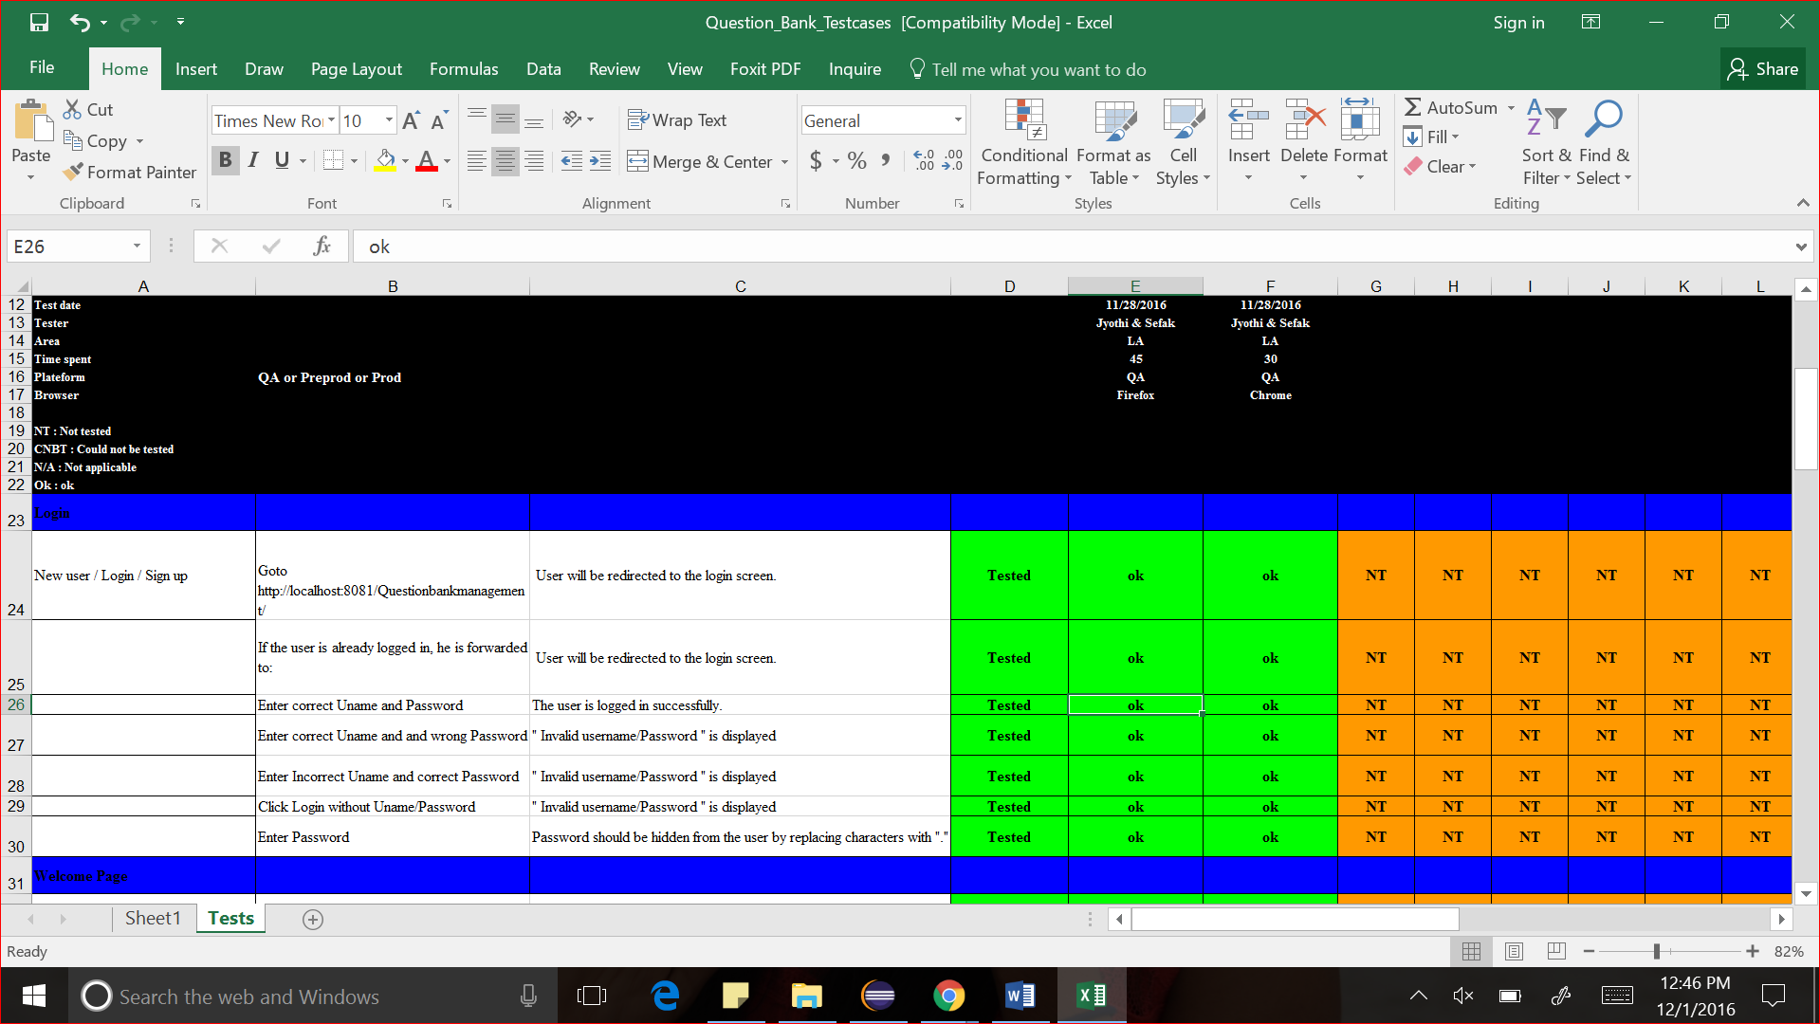

Fig 7.1: QBMS Test Cases Report

**Web Pages**

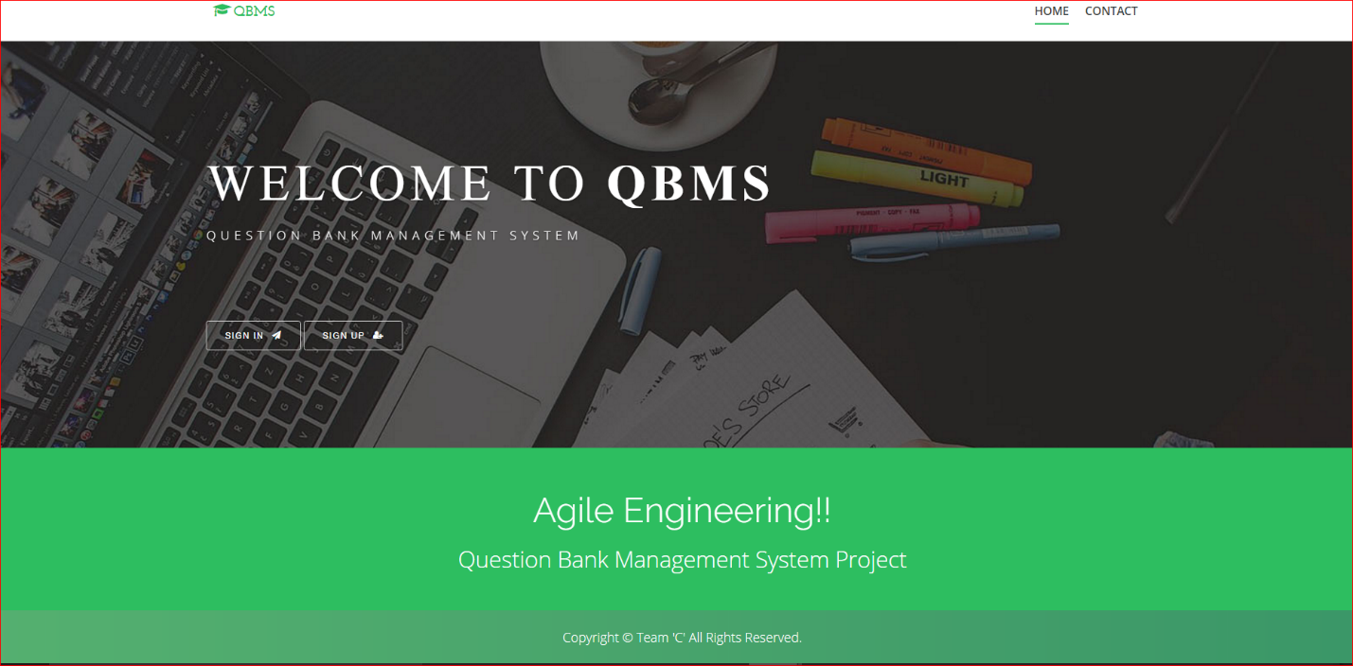

Fig 7.2 : Home Page

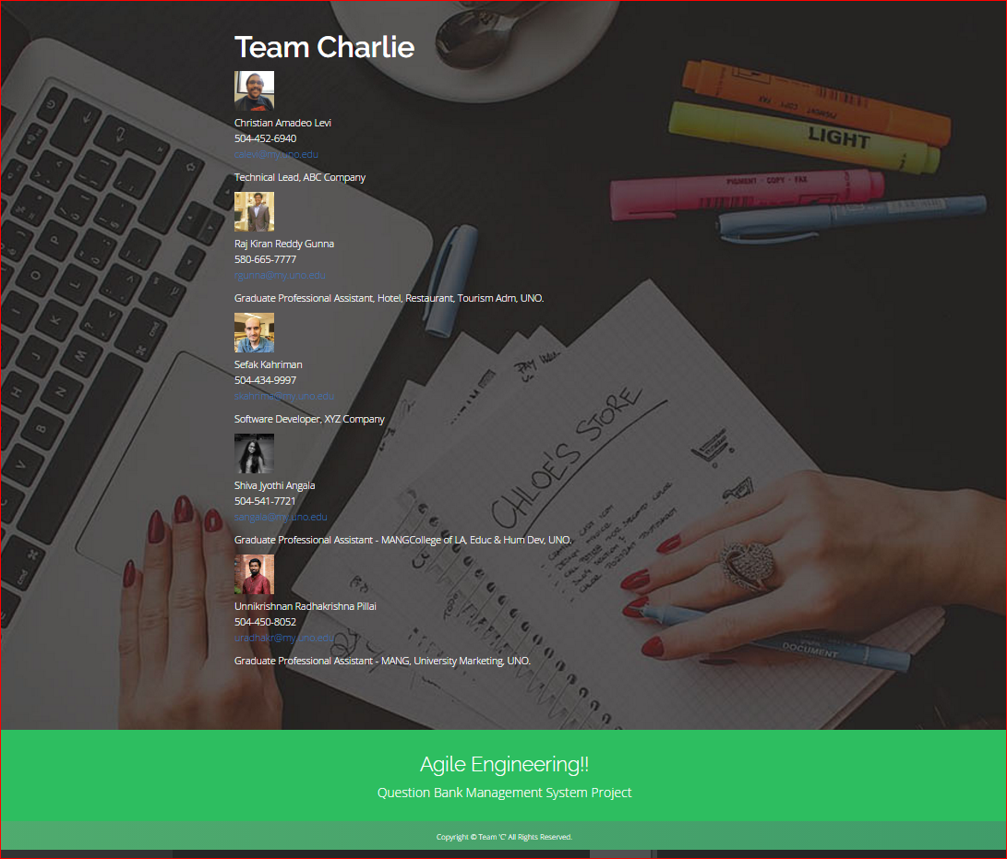

Fig 7.3: About Team

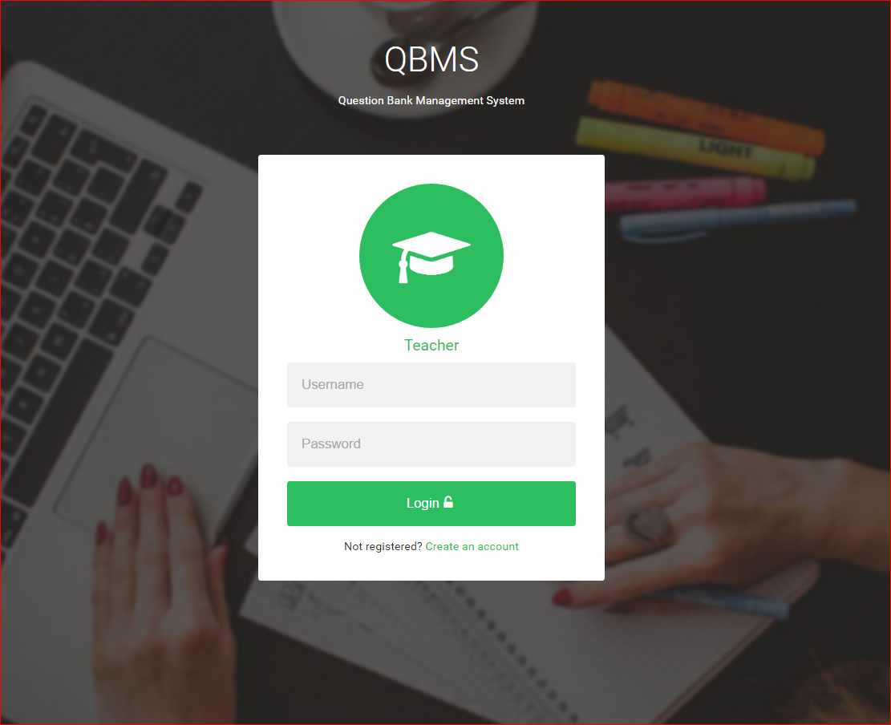

Fig 7.4: Login Page

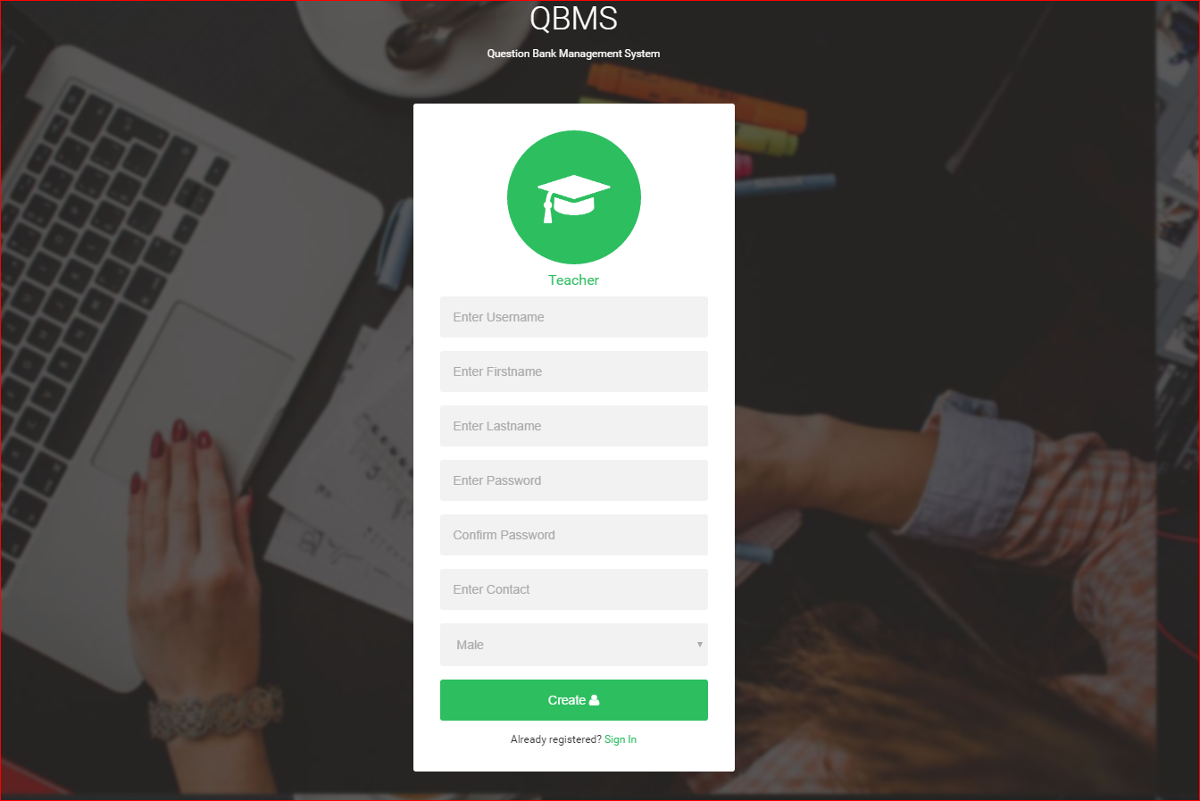

Fig 7.5: signup page

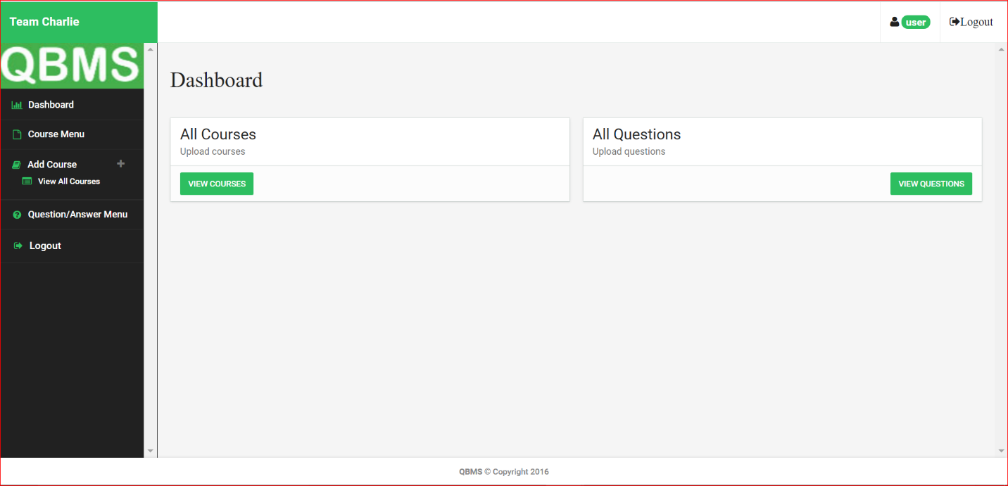

Fig 7.6: User Dashboard

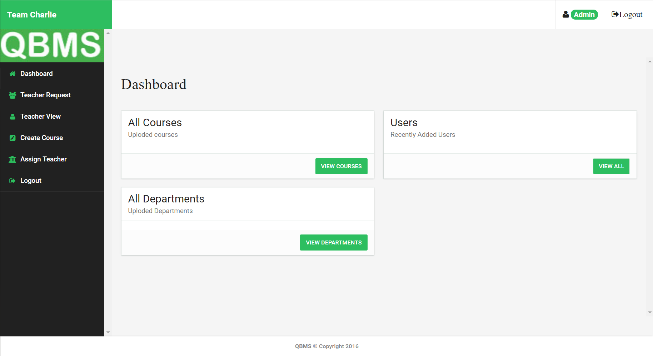

Fig 7.7: Admin Dashboard

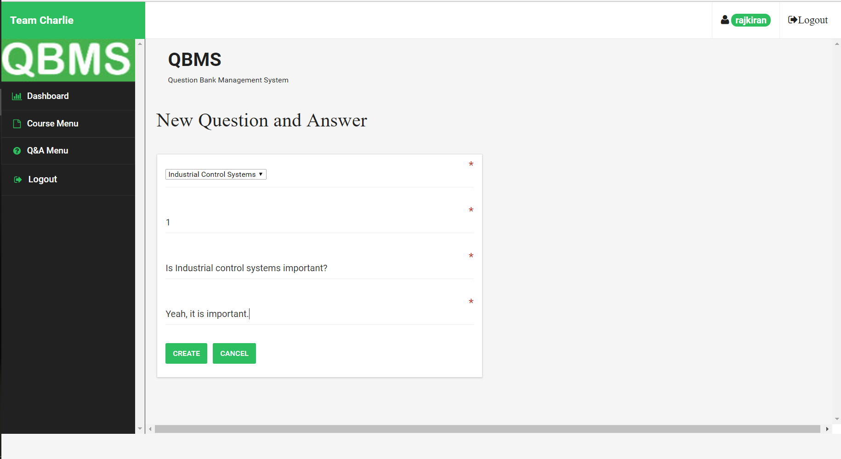

Fig 7.8: Adding Q&A

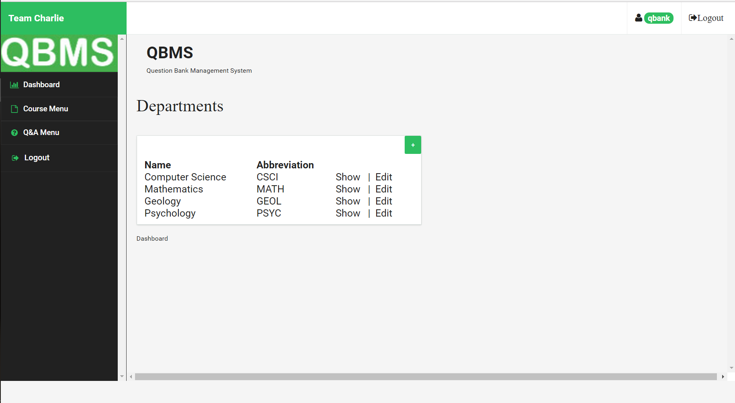

Fig 7.9: view all departments

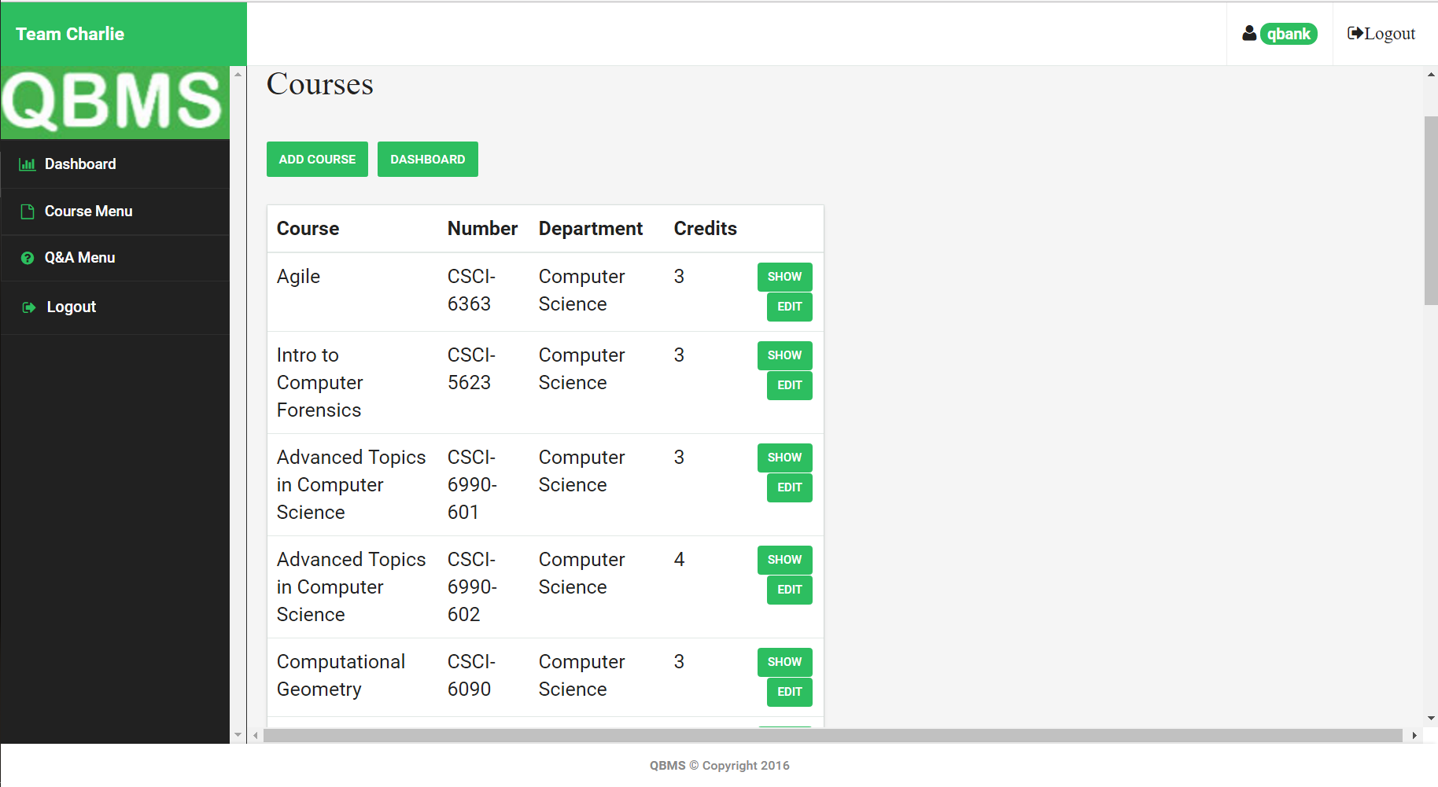

Fig 7.10: view all Courses

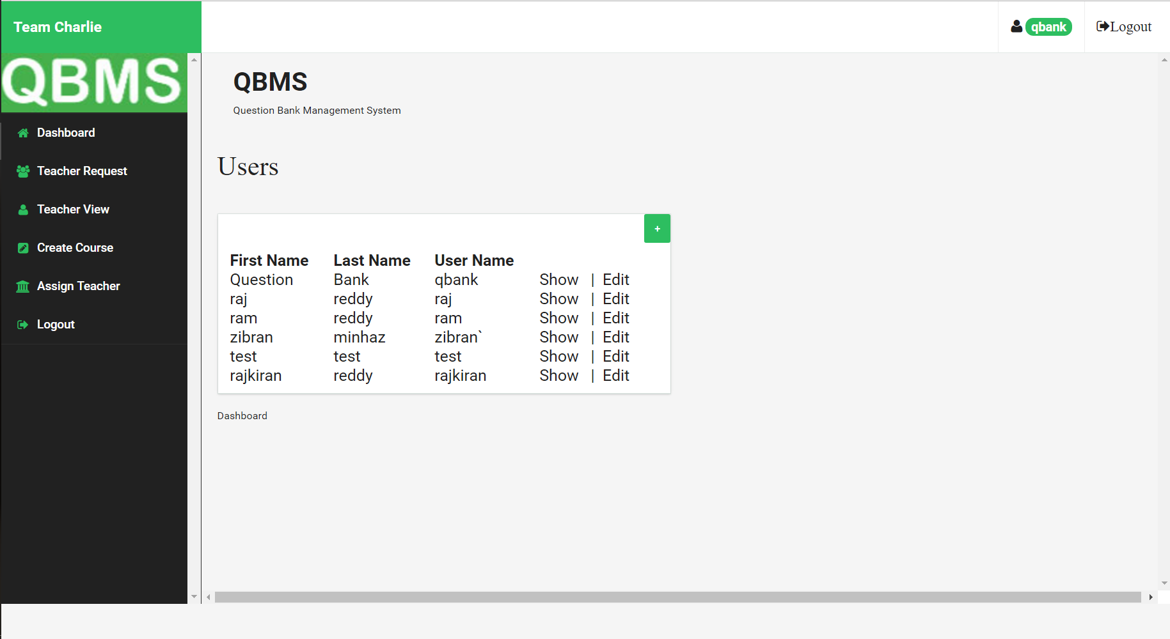

Fig 7.11: view all users

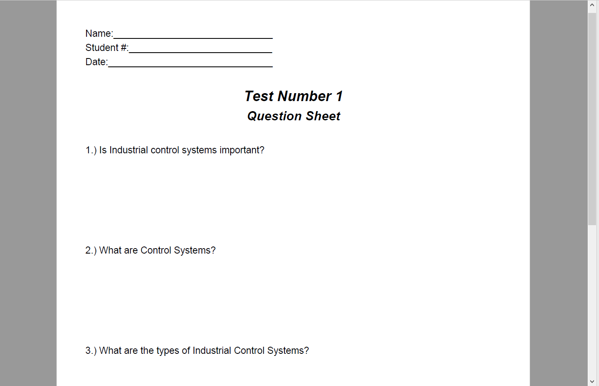

Fig 7.12: Question paper

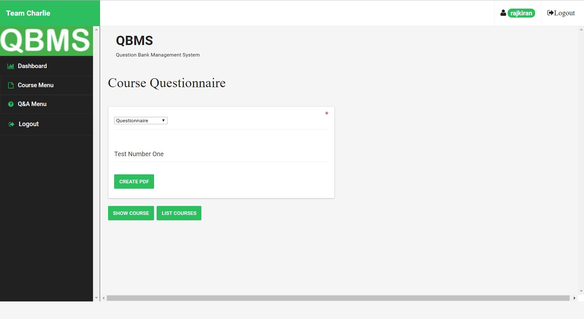

Fig 7.13: Create PDF



Fig 7.13: About Team

**8.REFERENCES**

* <https://en.wikipedia.org/wiki/Agile_software_development>
* <http://stackoverflow.com/>
* <https://taiga.io/>
* <https://en.wikipedia.org/wiki/Code_coverage>
* <https://gitlab.com/>
* <https://jenkins.io/>